**COSC 1200 – Object Oriented Programming 1**

**Section 06 (Winter 2024)**

**In Class Exercise 4**

In this ICE you will practice creating a simple UI using Java-Swing and follow guidelines discussed in class. Using Java-Swing create a UI that will simulate a login operation. You have to enter your first name in a text field as user name (use JTextField) and your student number as password (use JPasswordField). Your UI should also have a button. When the user presses on the button the program needs to display suitable message based on the valid or invalid entries of the user’s name and password. If the user’s name and password are correct display “Your User name and Password are correct” in a regular message box. If the user’s name and/or password are incorrect display “User name or Password is Incorrect” in a warning message box. Make sure to change the names of the UI components to useful ones and to use meaningful labels. Also make sure that that UI is presentable (good size ratios).

Refer the screen shots of the output and produce your output accordingly.

**Output 1: Valid User name and Password**

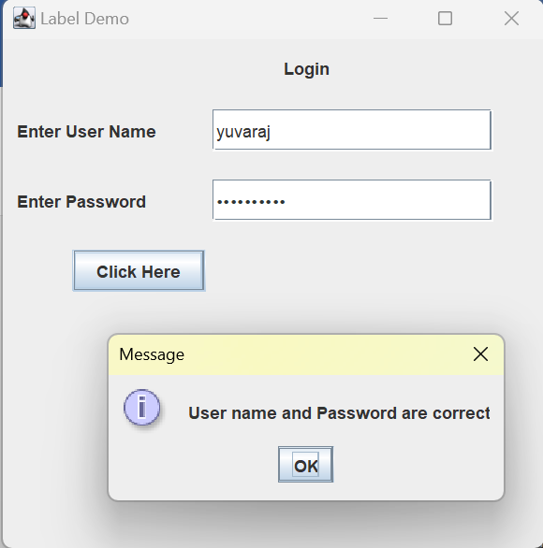

**Output 2: Invalid User name or Password**

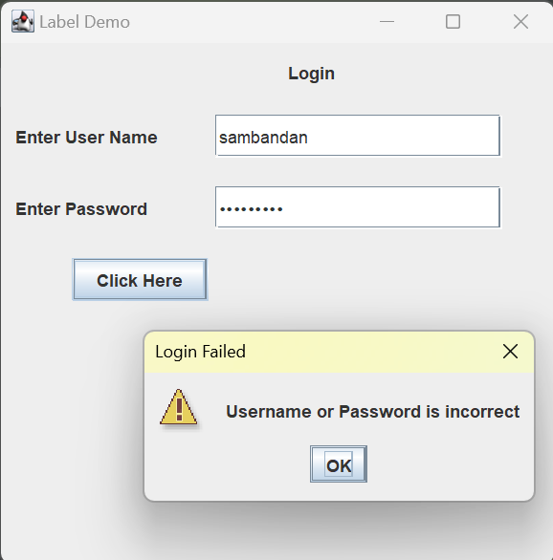

# General Requirements

* Include an opening comment with your name, the name of the program, the date, and a short description.
* Follow the style guide! Use descriptive names and sensible datatypes for variables, constants, arrays, functions, etc. that follow our naming conventions. Use good spacing and make sure braces ({}) are located where they are supposed to be.
* Take screen shots of your code, User-Interface, and its output. Put them in a word document or pdf. The screenshots must be clear. You can also copy the code and paste in the word or pdf with the screen shot of the output.

# Submission

* Make sure to submit your work on DC connect.
* Submit your .java files and the screenshot as single document, no zip files please.
* Grades will be granted according to class coding guidelines, professionalism, output clarity and solution ingenuity.